**[33] Design DFA Which Have Sub String ‘ABC’ Over Inputs {A,B,C}**

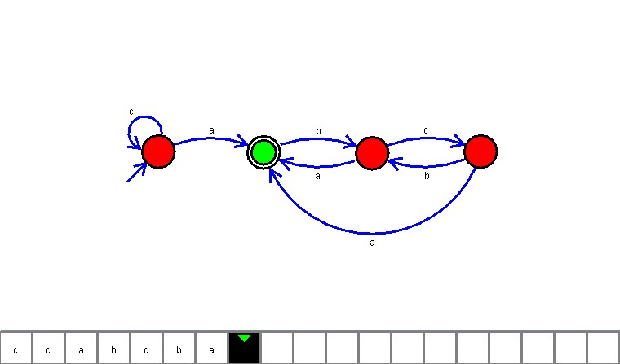

**Result**

The DFA is designed to compute the strings as input using Automaton Simulator